EXPERIMENTAL COMPETITION
January 10, 2024

Please read the instructions first:

- The Experimental competition consists of one problem. This part of the competition lasts 3 hours.
- Please only use the pen that is provided to you.
- You can use your own non-programmable calculator for numerical calculations. If you don’t have one, please ask for it from Olympiad organizers.
- You are provided with Writing sheet and additional papers. You can use the additional paper for drafts of your solutions but these papers will not be checked. Your final solutions which will be evaluated should be on the Writing sheets. Please use as little text as possible. You should mostly use equations, numbers, figures and plots.
- Use only the front side of Writing sheets. Write only inside the bordered area.
- Fill the boxes at the top of each sheet of paper with your country (Country), your student code (Student Code), the question number (Question Number), the progressive number of each sheet (Page Number), and the total number of Writing sheets (Total Number of Pages). If you use some blank Writing sheets for notes that you do not wish to be evaluated, put a large X across the entire sheet and do not include it in your numbering.
- At the end of the exam, arrange all sheets for each problem in the following order:
- Used Writing sheets in order.
- The sheets you do not wish to be evaluated.
- Unused sheets.
- The printed problems.
Place the papers inside the envelope and leave everything on your desk. You are not allowed to take any paper or equipment out of the room.

Superposition of oscillations
Devices and equipment: tripod, complex pendulum, ruler of 30 cm, electronic stopwatch.
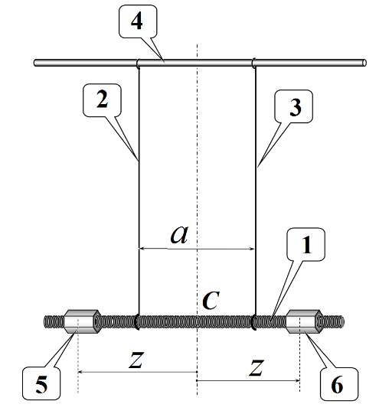
The oscillatory system is a torsion pendulum, which consists of a metal screw-threaded rod 1, suspended on two threads 2 and 3 of equal length, the threads are tied to a horizontal rod 4, fixed in the tripod leg. On the movable rod 1 there are two elongated screw nuts 5 and 6, which can be freely moved along the rod.
In all experiments, the lengths of the threads must remain unchanged, and they themselves must be strictly vertical in a state of equilibrium and located symmetrically relative to the center of the rod $C$. We denote the distance between the threads as $a$.
The screw nuts should also be positioned symmetrically relative to the center of the rod. The position of the nuts is determined by the distance $z$ from the rod center to the middle of the nut. For precise positioning of the nuts, it is recommended to use a rod thread with a pitch of 1.0 mm. For convenience, one of the faces of the nut is sealed with a strip of paper on which its middle is clearly marked, so that when the nut is turned one turn, it moves along the rod by a distance of 1.0 mm.
In this experiment you need to study two types of the rod oscillations:
- longitudinal oscillations (1 in the figure below), in which the rod and threads always move in the same vertical plane;
- torsional oscillations (2 in the figure below), in which the rod rotates around a fixed vertical axis passing through the rod center.

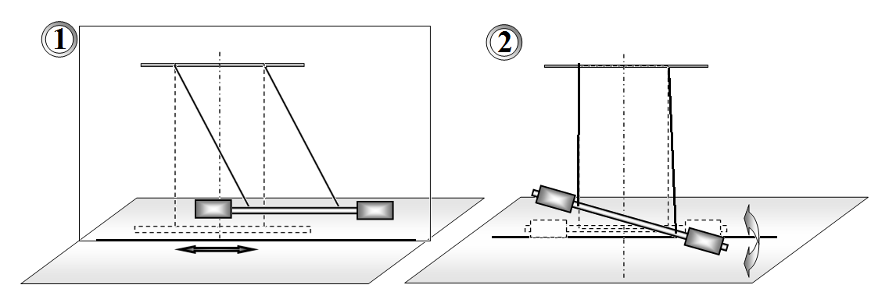

If the rod is deflected in a vertical plane and released, it then performs longitudinal oscillations. If the rod is rotated at a certain angle around the vertical axis and released, it then performs torsional oscillations.
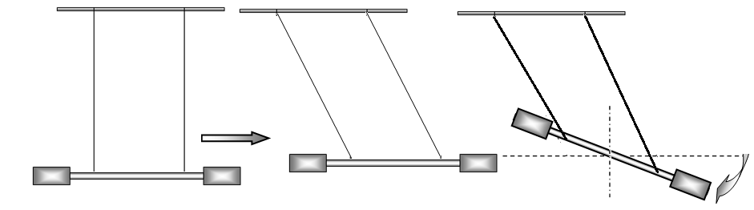
In addition, this experiment is aimed at studying the superposition of longitudinal and torsional oscillations, which can be excited by displacing the rod along its axis and rotating it at a certain angle relative to the vertical axis. We call such oscillations mixed.
For convenience, secure the pendulum in a tripod so that the rod moves in close proximity to the table surface. Place a sheet of paper on the table, on which you have to draw a straight line corresponding to the rod equilibrium position. During longitudinal oscillations, the rod must move along this straight line; during torsional oscillations, the center of the rod must be located on the same vertical.
During the experiments, the angles of deviation of the threads from the vertical during longitudinal oscillations and the angles of rod rotation during torsional oscillations should lie in the range of 20°-30°.

Successful completion of this experiment requires high precision measurements, so be extremely careful and accurate! Release the rod without any additional push!

Part 1. Observation of the effect and its theoretical description
Place the threads at a distance of $a=20$ cm, their lengths should approximately be $L=45$ cm, and the screw nuts should be placed at the ends of the movable rod. Excite mixed oscillations of the rod and carefully observe the movement of one of its ends. Since, with the selected system parameters, the frequencies of longitudinal and torsional oscillations are close, the shape of the trajectory of the rod end changes slowly and regularly, periodically returning to the initial one. Let us call the process of sequential restoration of the original shape of the trajectory a cycle, the corresponding time as the cycle time $T_{C}$, and the number of complete longitudinal oscillations corresponding to it as $N_{C}$.
1.1 Draw several successive characteristic shapes of the rod end trajectories in one cycle.
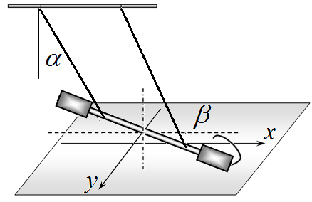
We introduce a coordinate system on the horizontal plane: the $x$ axis is directed along the rod in the position of its equilibrium, the $y$ axis is perpendicular to it, and the origin is placed under the center of the rod in the position of its equilibrium.
We also denote the angle of deflection of the threads during longitudinal oscillations as $α$, the angle of rod rotation during torsional oscillations as $β$, the period of longitudinal oscillations as $T_{0}$, the period of torsional oscillations as $T_{1}$, the length of the threads as $L$, and the length of the rod as $l$.
1.2 Write down the exact dependences of the coordinates of the rod end $x(t)$ and $y(t)$ on time $t$, and then obtain the corresponding approximate expressions for the conditions of this experiment.
1.3 Within the framework of the proposed model, obtain a formula for the cycle period $T_{C}$, expressing it through the periods of longitudinal $T_{0}$ and torsional $T_{1}$ oscillations.
1.4 Write down the formula for the number of longitudinal oscillations in the cycle $N_{C}$, expressing it in terms of periods $T_{0}$ and $T_{1}$.
Part 2. Longitudinal oscillations
2.1 Measure the period of longitudinal oscillations $T_{0}$ with the possible minimal error. Calculate the instrumental, random and total errors of the measured value of the period ${∆T}_{0}$.
Part 3. Torsional oscillations
The period of torsional oscillations can be described by the formula:
$\frac{T_{1}}{T_{0}}=a^{q}F(z)$, (1)
where $z$ signifies the distance from the rod center to the centers of the nuts, and $F(z)$ stands for a function that depends on $z$ only.
3.1 Measure the dependence of the period of torsional oscillations $T_{1}$ on the distance between the threads $a$, plot a graph of the resulting dependence. Take measurements when the nuts are at the rod ends with $z=17$ cm.
3.2 Based on experimental data, prove the validity of formula (1) and determine the exponent $q$. An error estimate is not required here.
It can be shown that the function $F(z)$ in formula (1) has the following form
$F\left(z\right)=\sqrt{A+Bz^{2}}$, (2)
where $A,B$ refer to some constant values independent of the parameters $a$ and $z$.
3.3 Fix the suspension threads at a distance of $a=10$ cm. Measure the period of torsional oscillations as a function of the position of the nuts $z$. Plot a graph of the resulting relationship. It is unnecessary to take measurements when the nuts are closer to the center of the rod than the threads.
3.4 Prove the applicability of formula (2) to describe your experimental data.
3.5 Calculate the values of the coefficients $A,B$ and estimate their errors. Please note that $a,z$ values must be measured in centimeters.
Part 4. Mixed oscillations
Place the threads at a distance of $a=20$ cm. Investigate the mixed oscillations described in Part 1 for different positions of the nuts with $z>10$ cm.
4.1 Measure the dependence of the number of longitudinal oscillations in the cycle $N_{C}$ on the position of the nuts $z$. You may not be able to do this for all $z$ values!
4.2 Based on the results of parts 2 and 3, calculate the periods of torsional oscillations for all values of $z$ at which the measurements have carried out in section 4.1.
4.3 Present the measurement results in such a graphical form that they confirm the validity of the formula for the $N_{C}$ value obtained in part 1.

