August 2022
IOAA
Georgia

Daytime Observation
Cover Sheet

O5 [9 Points]

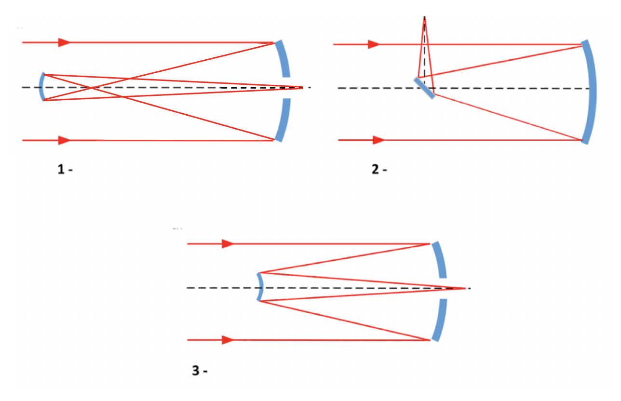
The image below shows schematic representations of three different types of reflectors.
For each one, choose the correct name from the list below. (3 points each)
(A) Newtonian (B) Pfund (C) Gregorian (D) Herschelian (E) Keplerian (F) Coudé (G) Galilean (H) Cassegrain
ccv
2. __________________________________________________________

3. __________________________________________________________

1. __________________________________________________________

O6 [21 Points]
The equatorial constellations are listed below. Fill in the missing ones in the correct order. Use the IAU codes or official names accepted by the IAU.

1. Serpens (Ser) 2. Ophiuchus (Oph) 3. ____________ 4. Aquarius (Aqr) 5. Pisces (Psc). 6. Cetus (Cet)7. ____________ 8. ____________ 9. ____________ 10. Monoceros (Mon) 11. Canis Minor (CMi)12. ____________ 13. ____________ 14. _____________15. Virgo (Vir)
Which of these 15 constellations are also on the ecliptic? If you give more than the required number of constellations, only the first ones you write (in order) will be considered.
ccv

O7 [20 Points]
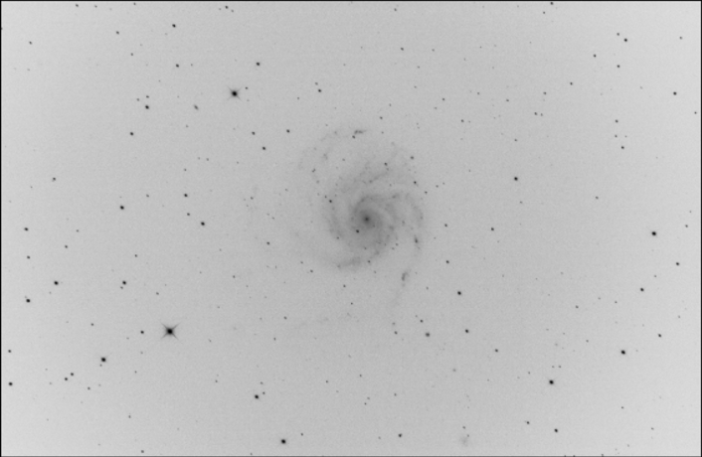
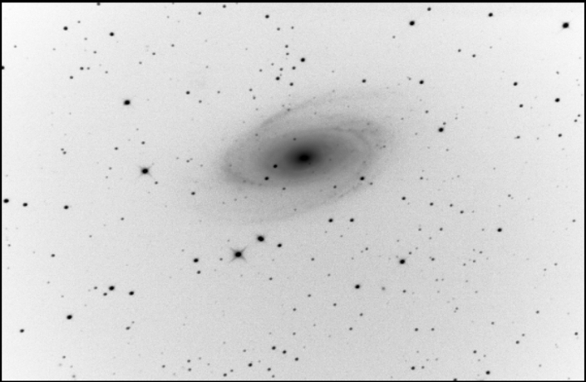
Write the numbers in Messier catalogue, and the constellations (IAU code) of the given Messier Objects (4 points for each object).
II
I
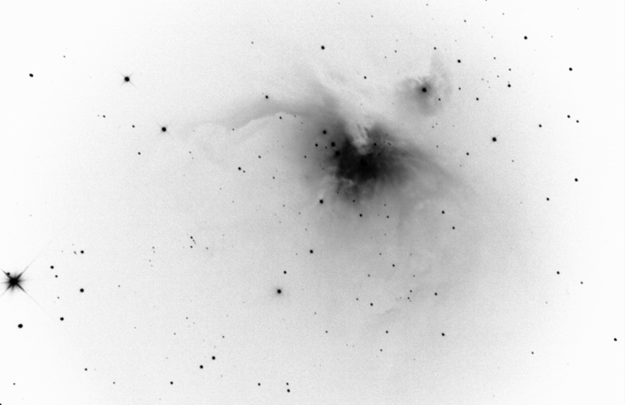
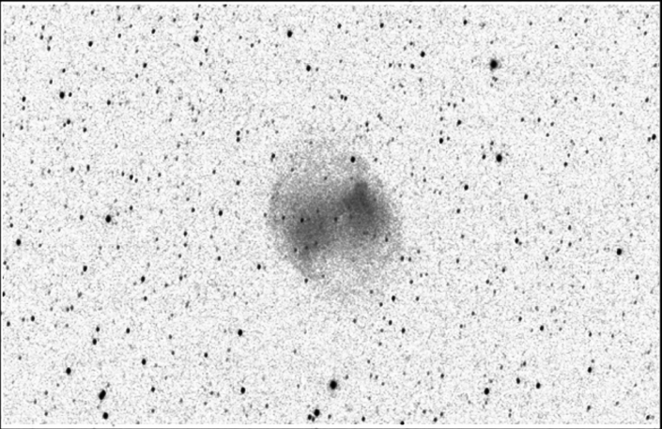
IV
III

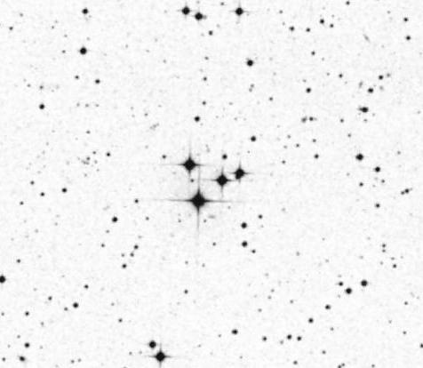

V
I __________________________________________________________

II __________________________________________________________

V __________________________________________________________

IV __________________________________________________________

III __________________________________________________________

O8 [30 Points]
There are three additional and two missing stars on the figure given below. Circle them and number them as 1, 2, 3 (additional stars), 4, 5 and 6 (missing stars).

O9 [5 Points]
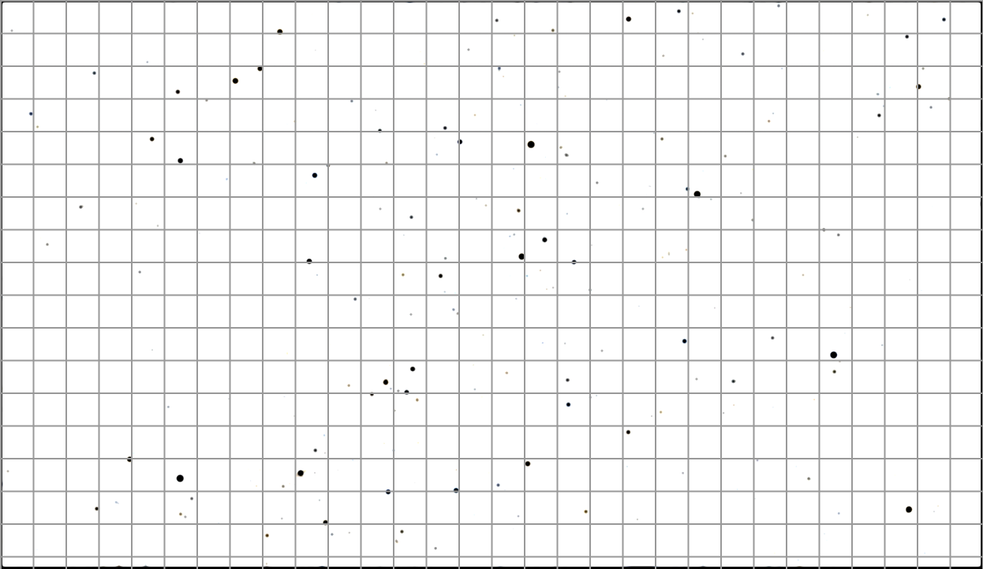
Calculate the time interval between the two figures given below if the first figure occurs earlier than the second one, and the time interval is less than one sidereal day
Initial
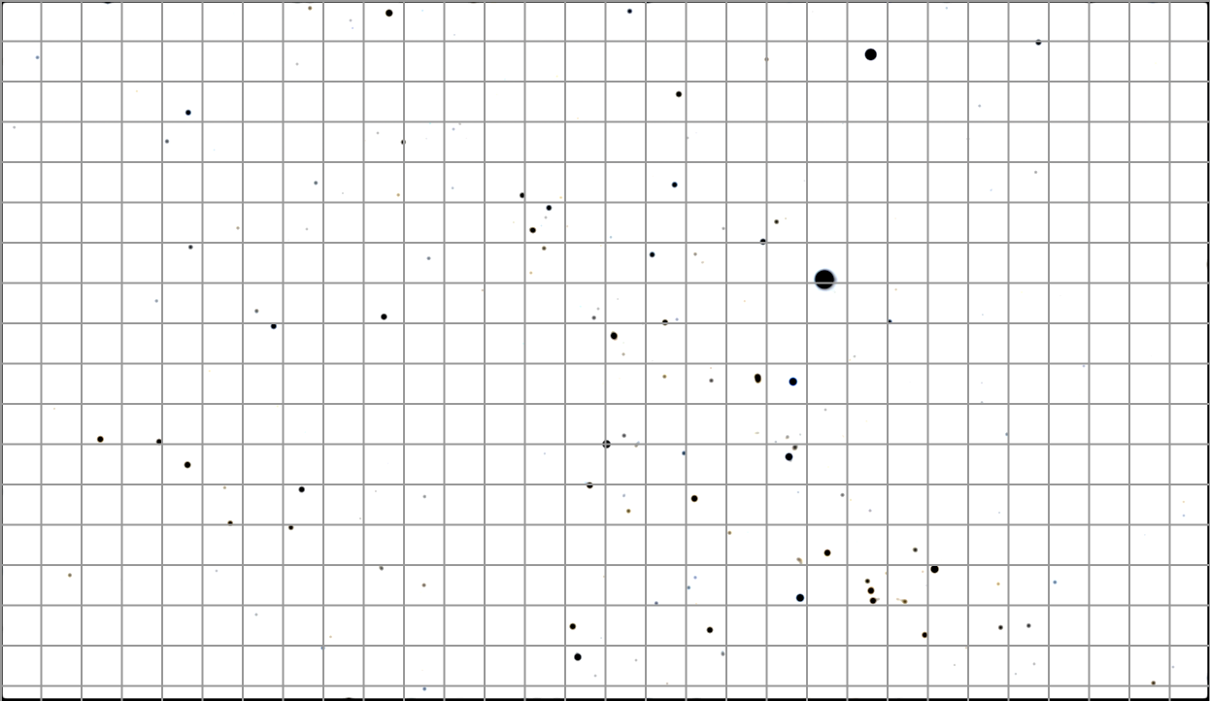
Final
ccv

