OBSERVATIONAL EXAM – 1ST NIGHT

1 – Use your green laser pointer to aim at the stars Antares (α-Sco), Vega (α-Lyr), Altair (α-) and Peacock (α-Pav). Also point to the constellation Corona Australis. (Duration: 3 min)

2 – Estimate the diameter of the field of view of this telescope, using 10mm Plössl eyepiece and star chart-1, showing nearby region of open cluster NGC 6231. On star chart 1 there are two angular distances shown. Use them as reference. Express your answer in arc minutes. (Duration: 5 min)

3 – Use star chart-2 to estimate the magnitude of the missing star, shown as a cross, inside NGC 6231. Use magnitude of other stars as reference.
Note: To avoid confusion between decimal dot and real stars, dots are supressed. So, magnitude 60 correspond to magnitude 6.0. Give your answer using one decimal scale and 0.1 precession. (Duration: 5 min)

4 – Point your telescope to the binary star ε Trianguli Australis using star chart-3 as guide. If you are not able to point at the star, the instructor will do it for you but you lose 50% of the points. That pair components are magnitude 4.1 and 9.3 separeted by 82”. Evaluate color of each star: (Duration: 2 min pointing, 3 min determining the color)

Brighter: White/blue ( ) Yellow ( ) Red ( )

Dimmer: White/blue ( ) Yellow ( ) Red ( )

5 – Individual telescopes will be pointed to some objects. Identiffy wich one correspond to: Open Cluster (OC), Globular Cluster (GC), Emission Nebulae (EN) and Planetary Nebulae (PN). (Duration: 2 minutes, 30’ per object)

Object 1 ( ) Object 3 ( )

Object 2 ( ) Object 4 ( )

CHART 1 - NGC 6231 Field of view

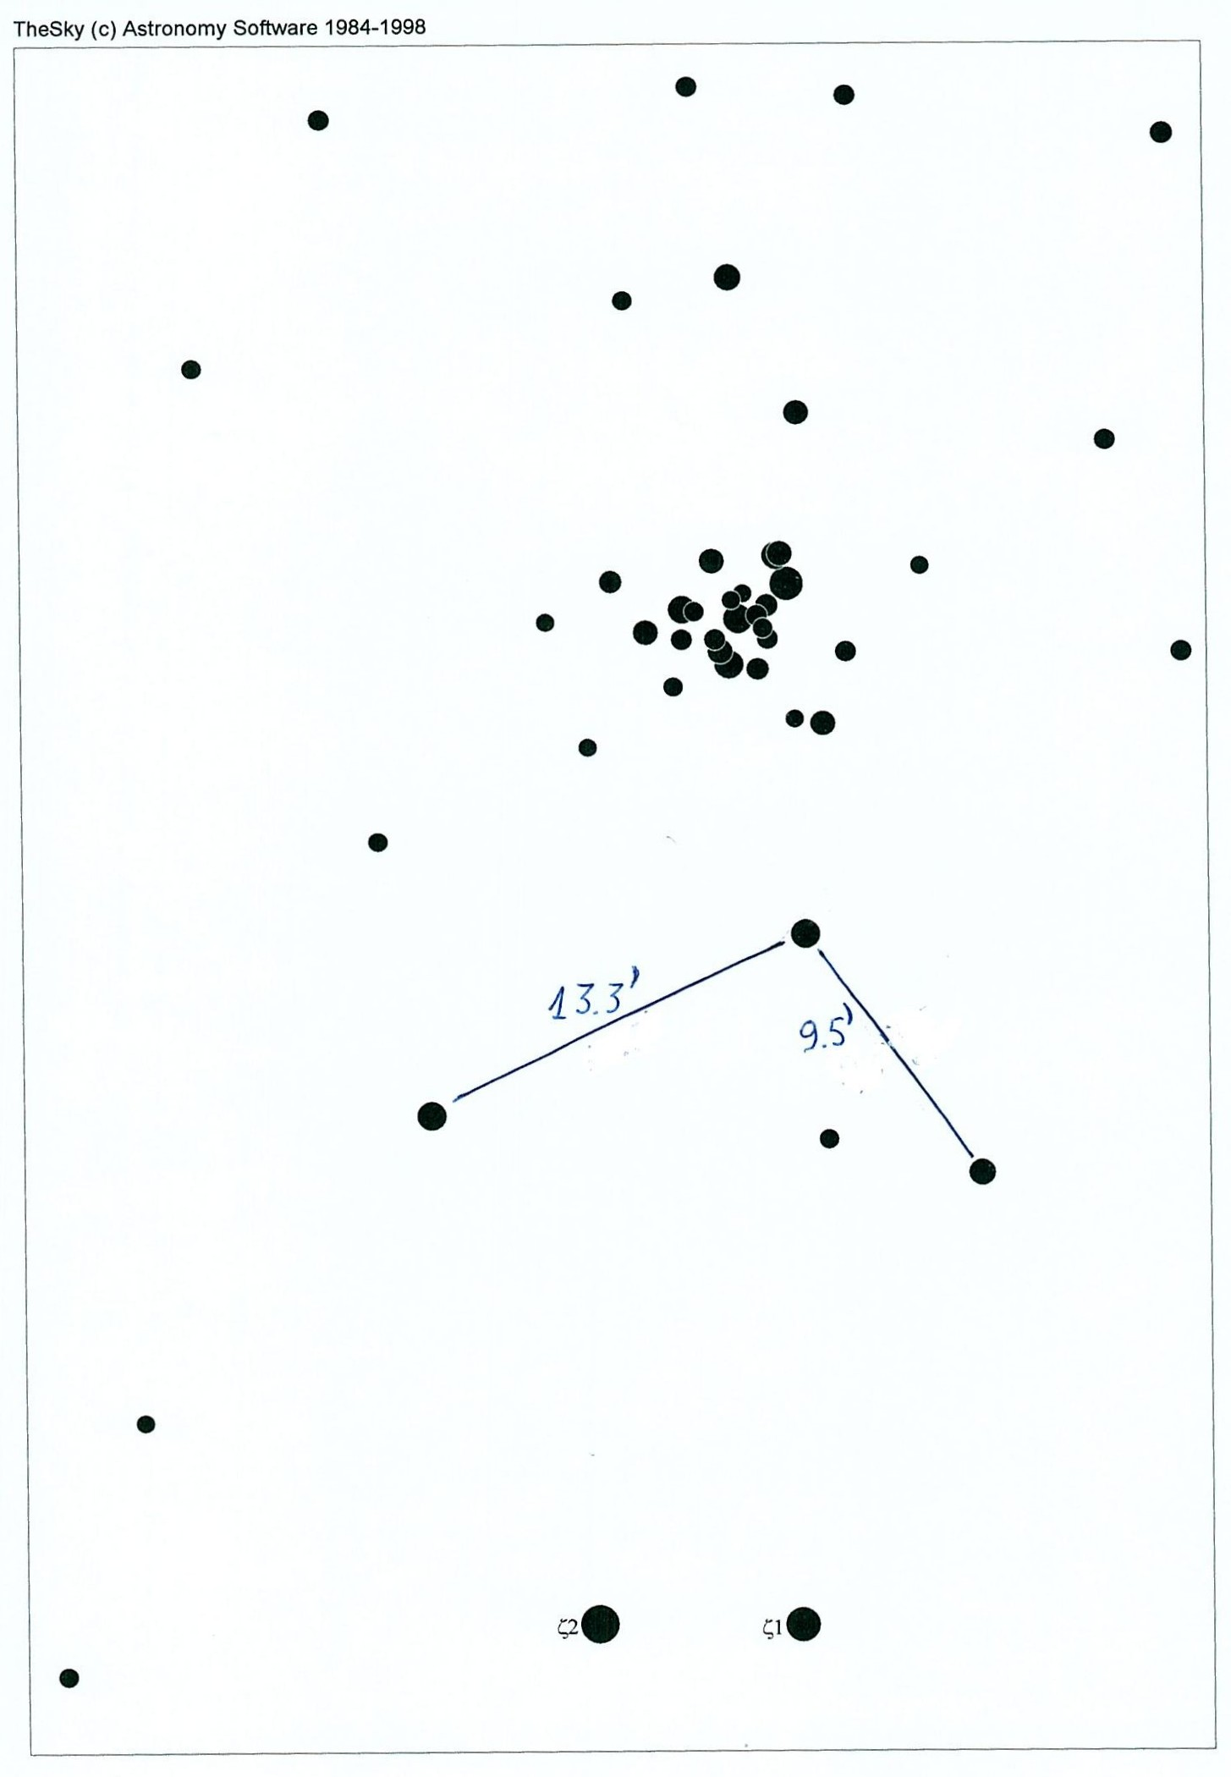

CHART 2 - NGC 6231 – Star magnitudes

CHART 3 - ε Trianguli Australis location

